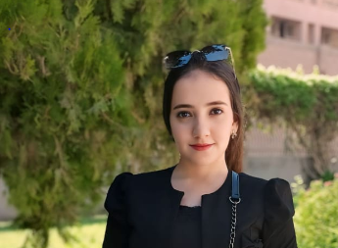

**Biography**

**marina fathy kamel melik**

***Department of psychiatry and mental health nursing, Faculty of nursing, Assuit University.***

**Personal Data :**

Name : marina fathy kamel melk

Graduation Year : 2022

Study at : Faculty of nursing Assuit University.

Date of birth : 16\9\2000

Phone number : 01276427440

Address : Assuit \ Manfalut

E-mail : [marina2000@aun.edu.eg](mailto:marina2000@aun.edu.eg)

[fathymarina42@gmail.com](mailto:fathymarina42@gmail.com)

***# Working as: Demonstrator at psychiatry and mental health nursing ,faculty of nursing , Assuit universit***

# Training & courses :

***Effective communication skills***

***The training program on publishing research in international journals***